- Create one Jenkins job using the below code and create three stages.
Connect to your instances
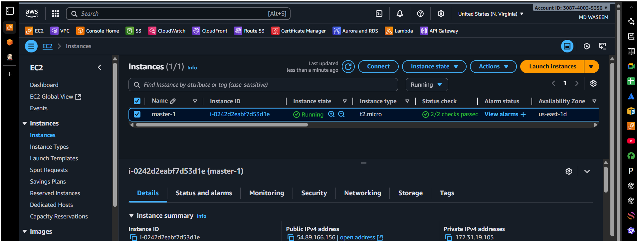
copy your public ip addressto run Jenkins toolat last of your Ip adrs type :8081/ Hite enteryou’ll navigate to your jenkins gui create a job Source Code Management_ git link https://github.com/betawins/VProfile-1.git
then save…!!!
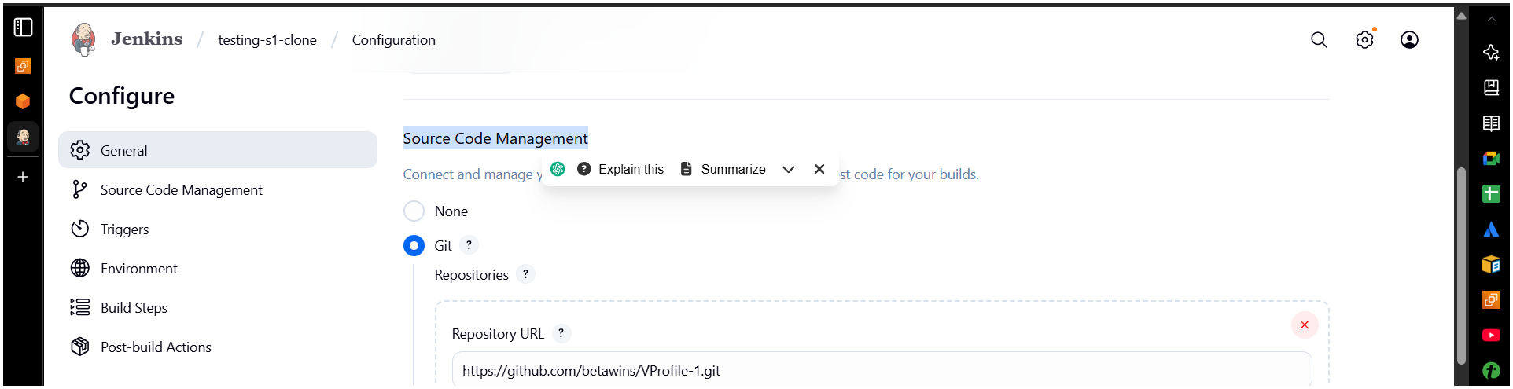
stage1: Git clone to download the source code.
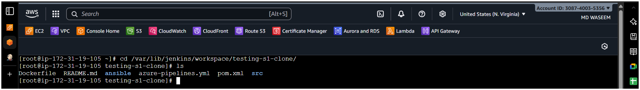
stage2: SonarQube Integration to check the quality of code
But first we need to have SonarQube server.
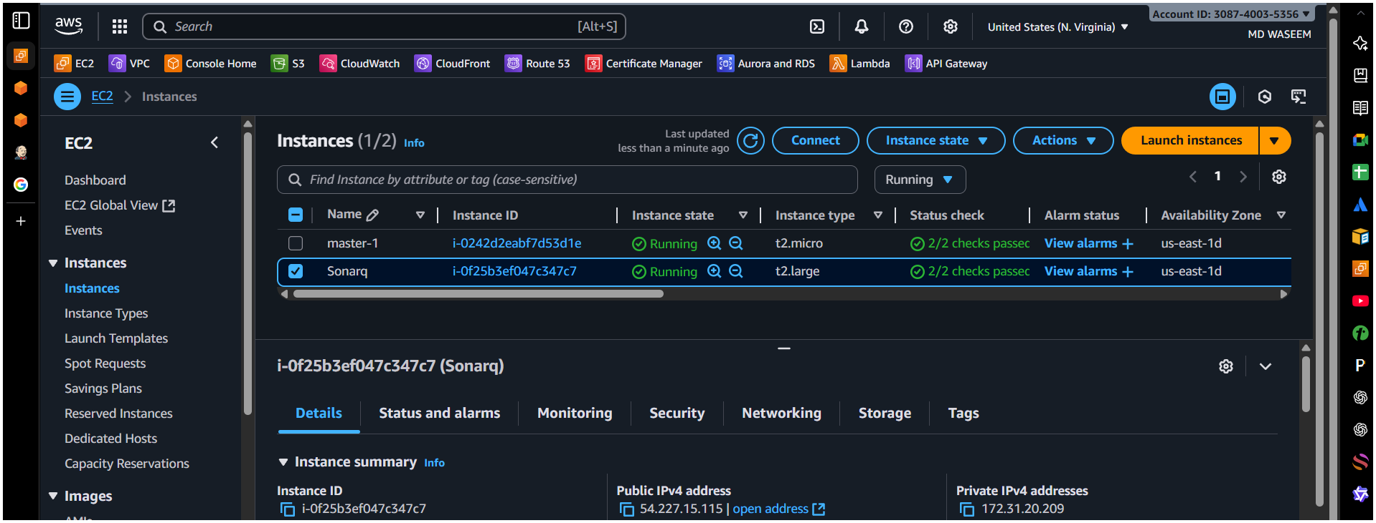
make sure you are adding this custom tcp 9000 in you (inbound rules)
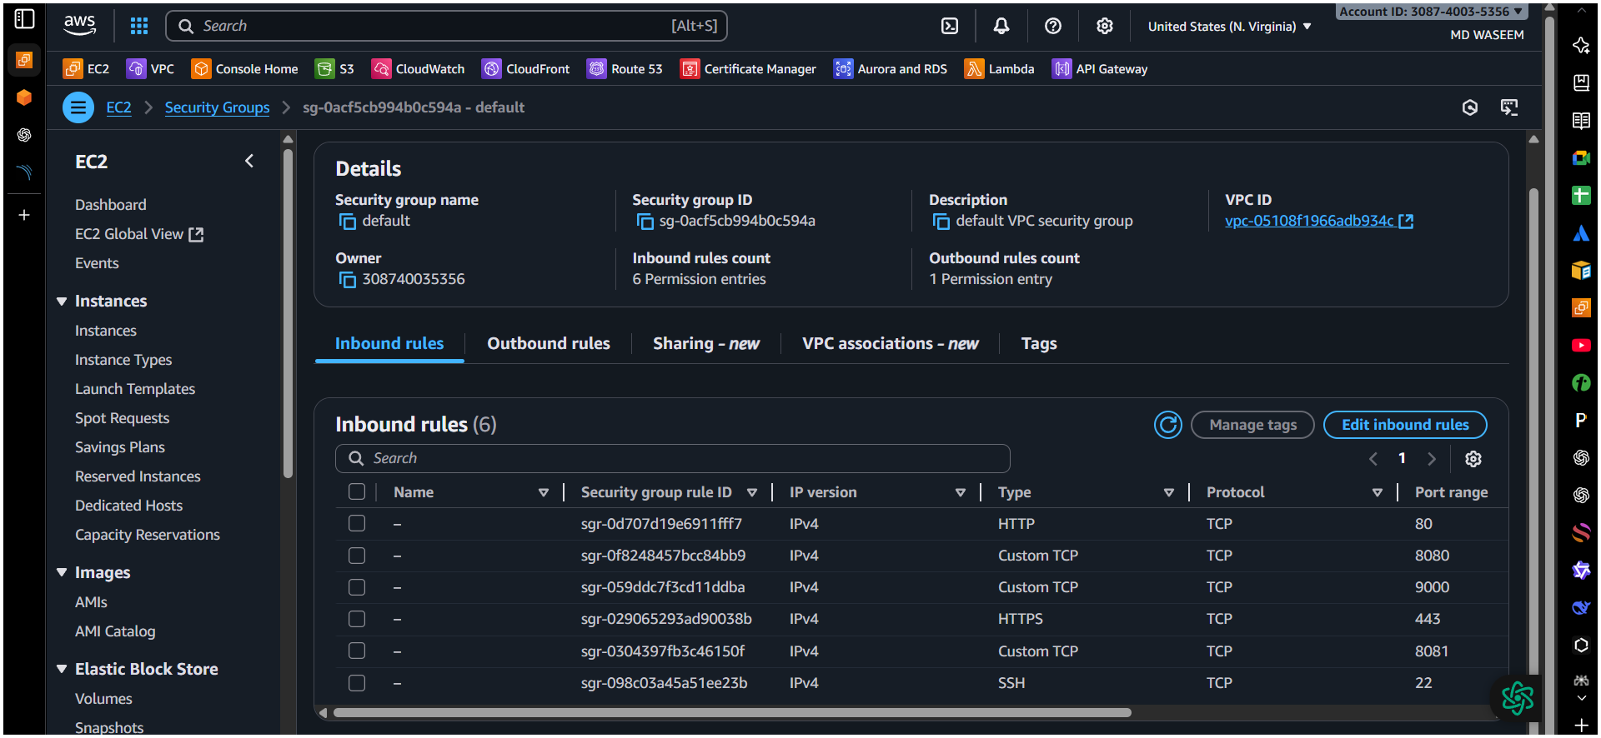
install java
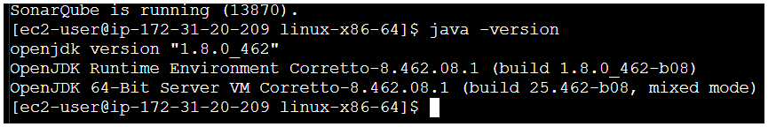
- yum install java-1.8*
Or
- sudo dnf install java-1.8.0-amazon-corretto -y

(the reason we’re using this 1.8 cause sir said the code support the only version / not sure)
Now install Mysql in your server machine(ec2).
yum update
sudo wget https://dev.mysql.com/get/mysql57-community-release-el7-11.noarch.rpm
sudo yum localinstall mysql57-community-release-el7-11.noarch.rpm
rpm --import https://repo.mysql.com/RPM-GPG-KEY-mysql-2022
sudo yum install mysql-community-server
sudo systemctl start mysqld.service
```
Start MySQL and Enable Start at Boot Time
systemctl start mysqld
systemctl enable mysqld
Check if mysql is running or not
netstat -na | grep 3306
Configure the MySQL Root Password
You will see default MySQL root password
grep 'temporary' /var/log/mysqld.log
or
sudo grep 'temporary password' /var/log/mysqld.log
Login to mysql using the default password
mysql -u root -p
Now replace the default password with a new and strong password
ALTER USER 'root'@'localhost' IDENTIFIED BY 'admin@00000';
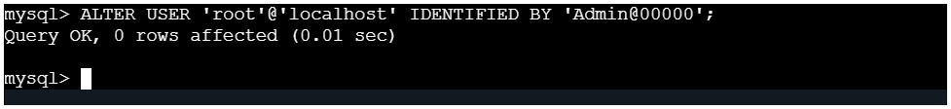flush privileges;
After changing the passcode/password check once.
mysql -u root -p

- Now We Need To Install SonarQube In Over Ec2 Machine.
Only make sure to install any of the packages try to change the
path from cd /opt
wget https://binaries.sonarsource.com/Distribution/sonarqube/sonarqube-6.6.zip
Unzip the file.
unzip sonarqube-6.6.zip
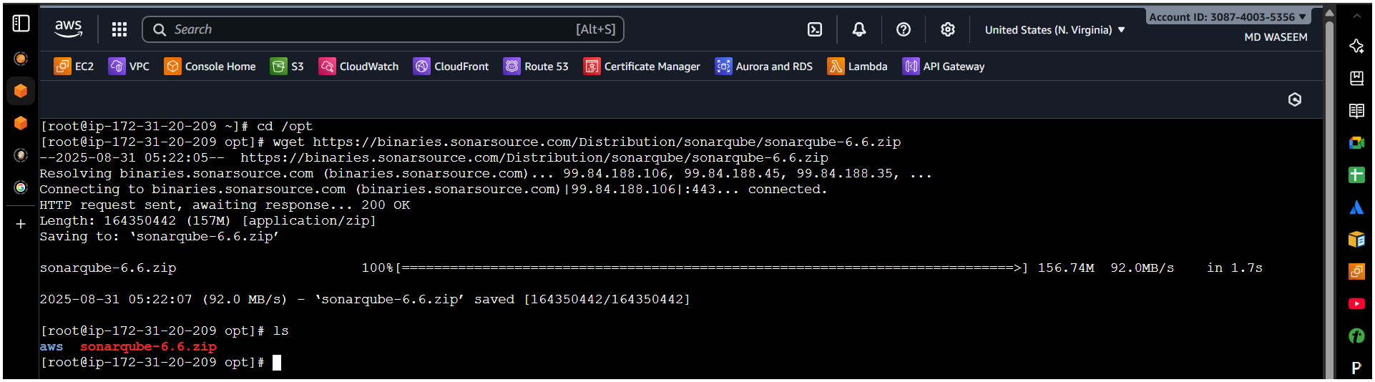
Rename the file / optional.
mv /opt/sonarqube-6.6 /opt/sonar

Try to login again to DB.
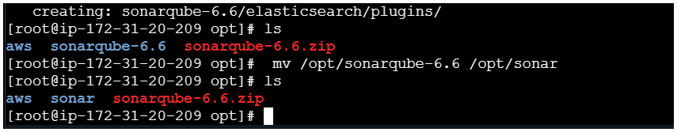
Create a new sonar database.
CREATE DATABASE Emran CHARACTER SET utf8 COLLATE utf8_general_ci;
Component | Meaning & Behavior
CREATE DATABASE sonar | Creates a new database named sonar
CHARACTER SET utf8 | Sets default text encoding to UTF-8 (3-byte, limited)
COLLATE utf8_general_ci | Uses general, case-insensitive ordering/comparison rules

Create a local and a remote user
CREATE USER sonar@localhost IDENTIFIED BY 'Emran@00000';
CREATE USER sonar@'%' IDENTIFIED BY 'Emran@00000';
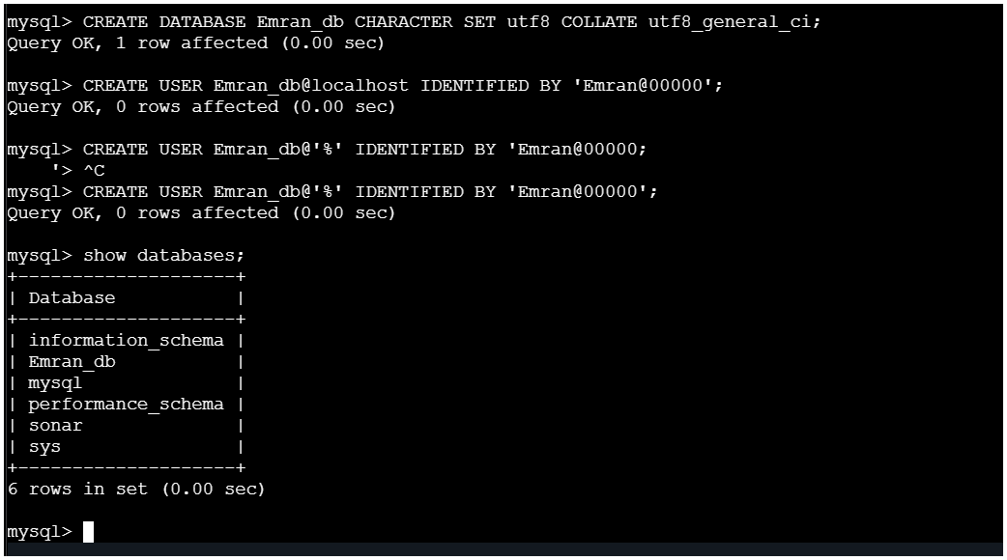
Grant database access permissions to users
GRANT ALL ON sonar.* TO sonar@localhost;
GRANT ALL ON sonar.* TO sonar @'%';
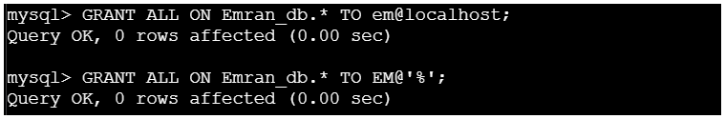

Check Users And Databases.
show databases;
SELECT User FROM mysql.user;
FLUSH PRIVILEGES;
QUIT
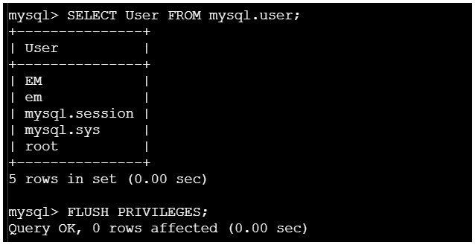
Now navigate to your sonar file to make changes related to your user name and password make the change as below;
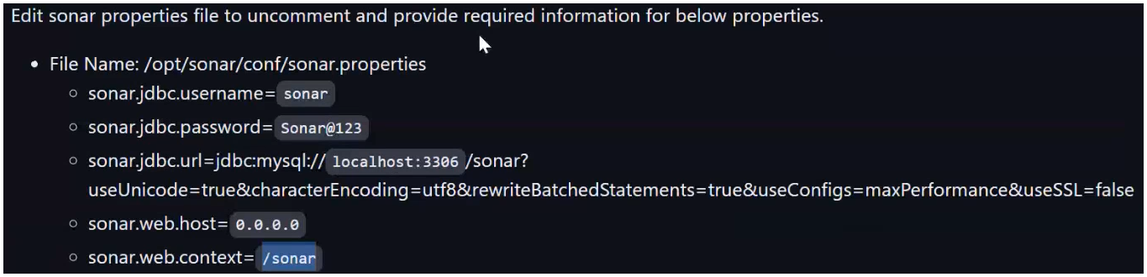
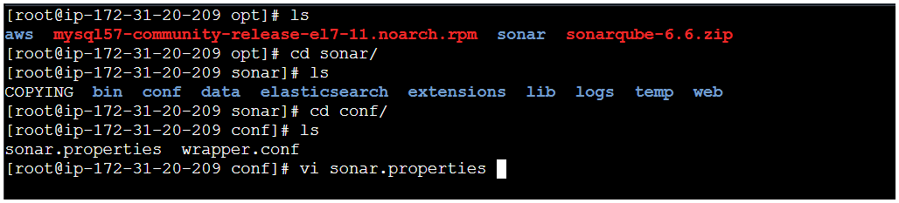
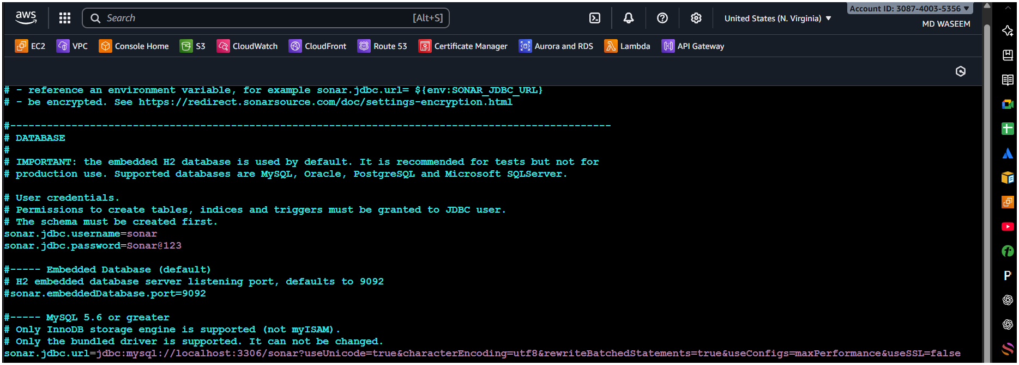
- Start SonarQube service
cd /opt/sonar/bin/linux-x86-64/
./sonar.sh start
switch to ec2-user cd/opt ll you’ll see all your files but here the file sonar we have install in root user ,Now here we need to change the root user to ec2-user(normal user) sudo chown -R ec2-user:ec2-user sonar now we can use this sonar file and start from normal user ____but why we’re starting the sonar Q from normal user ,Rather then we can do the same (start) in root user..?

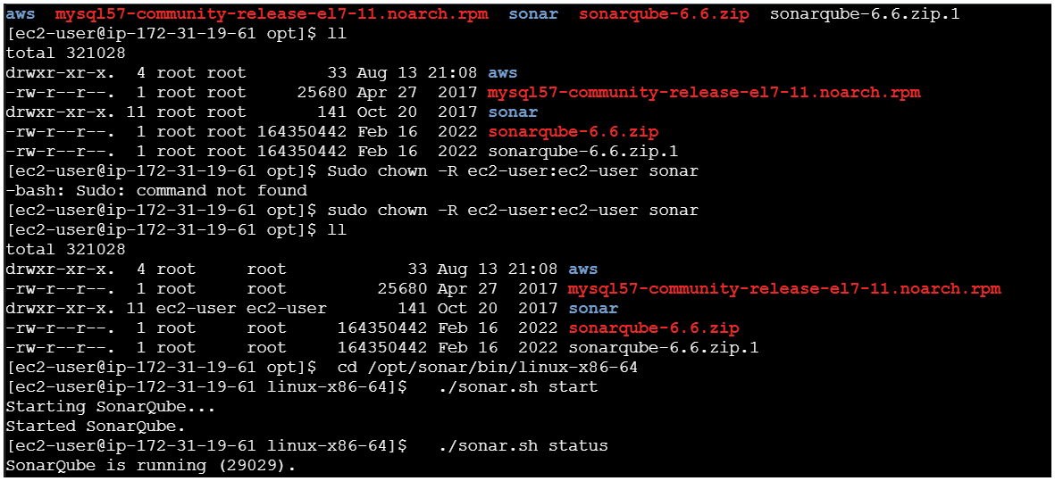
The Reason Why Sonarq Wasn’t Working Cause I Was Using The Java 17v Above To Fix I Tried To Remove The Java 17 And Then Again Tried To Install Again Java-1.8v.
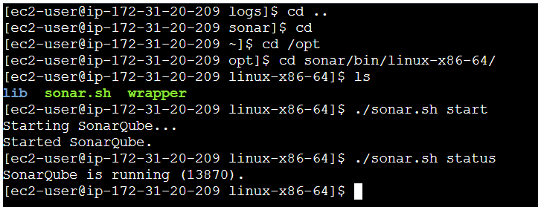
If You Get Any Error Related To Starting Problem Then Try To Check The File In
Cd Sonar Ls Access , Es , Sonar , Web Etc…..
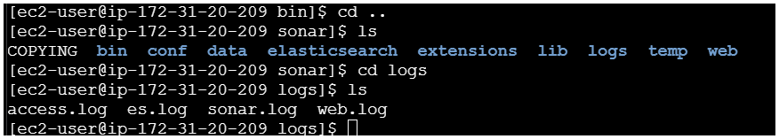
Finally Made Here after_5 hr Of Afford
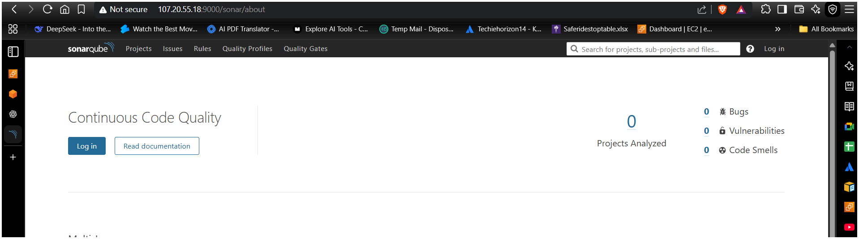
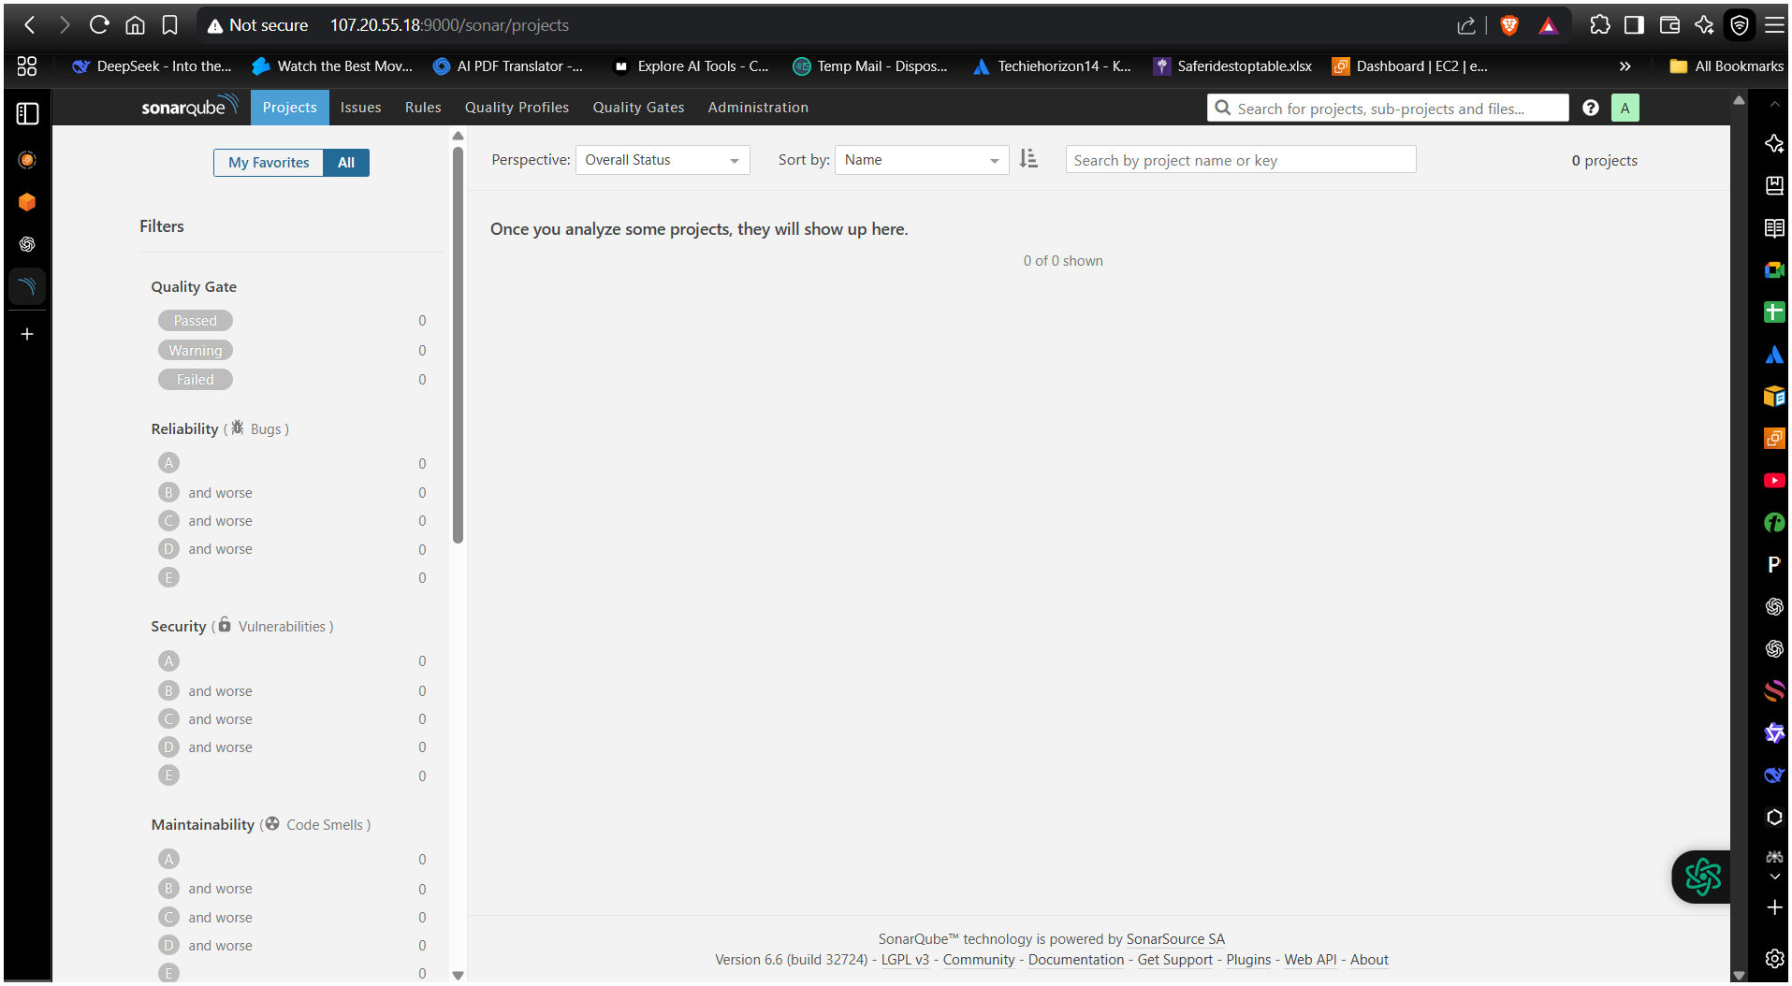
Select Sonar Gerrit (If You Would Get The Sonarqube_Scanner)
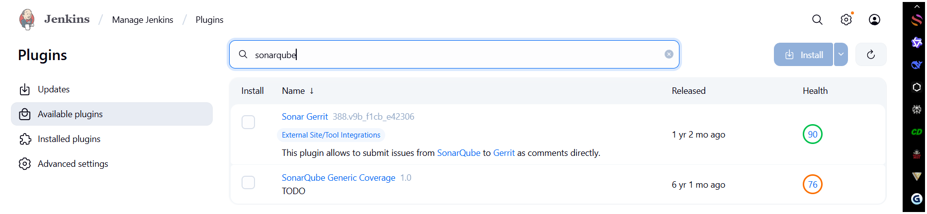

Here We Need To Generate Token From Sonarqube Gui My A/C SecurityGenerate Token.
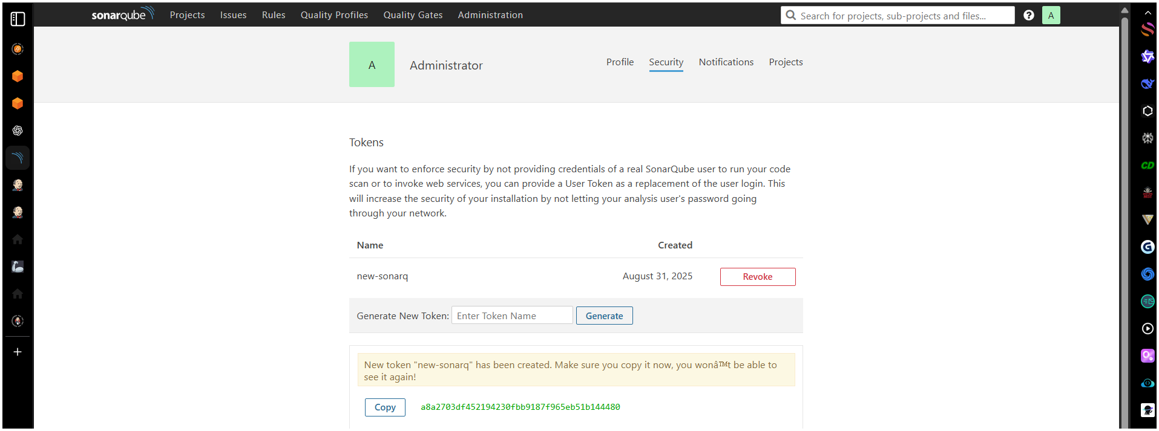

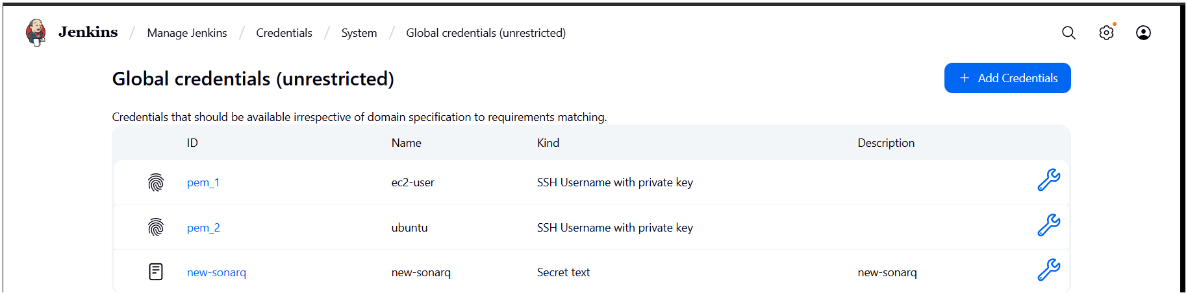
Now Navigate To Your Jenkins Manage JenkinsCredentialAdd Credential Select In Txt Format paste the code/token in secrete Save Then Again Go To Your Job (Testing-S1-Clone) Configuration Build Steps(Add Build Step)__Select Execute Sonarqube Scanner Add The URL Of Your SonarQube (http://107.20.55.18:9000/sonar) Add Credential / Select ItSave it ----!!!

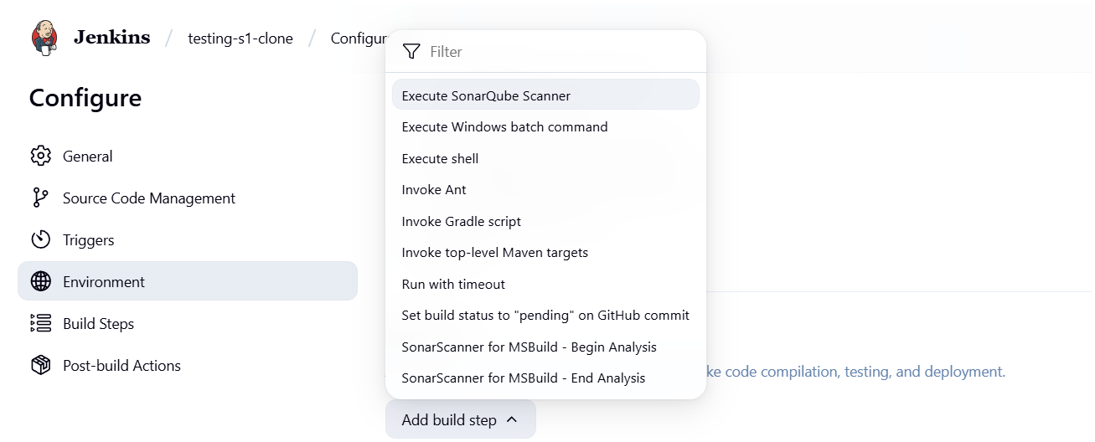

Now We Need To Install The SonarQube In Our Jenkins Server(Ec2)
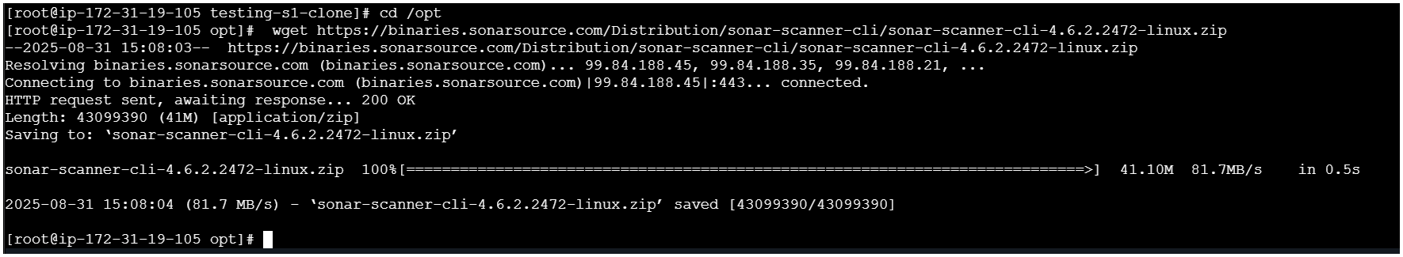
unzip sonar-scanner……zip
Rename The File _optional
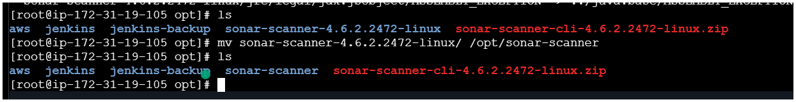
SonarQube Server Detail In Sonar-Scanner Proper File
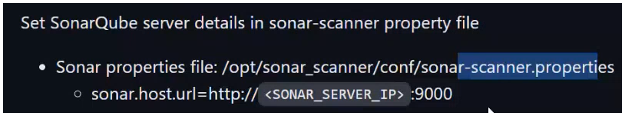
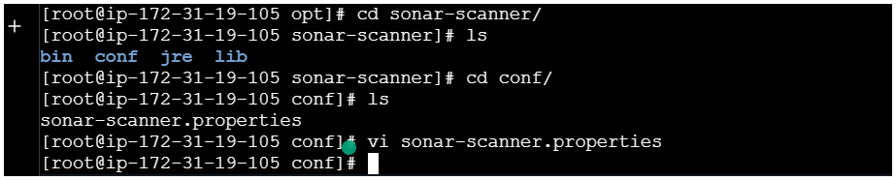
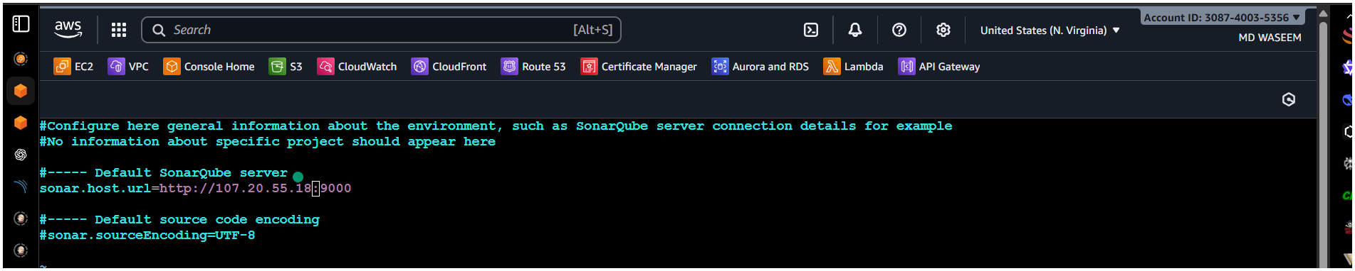
Now again
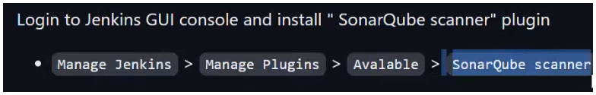
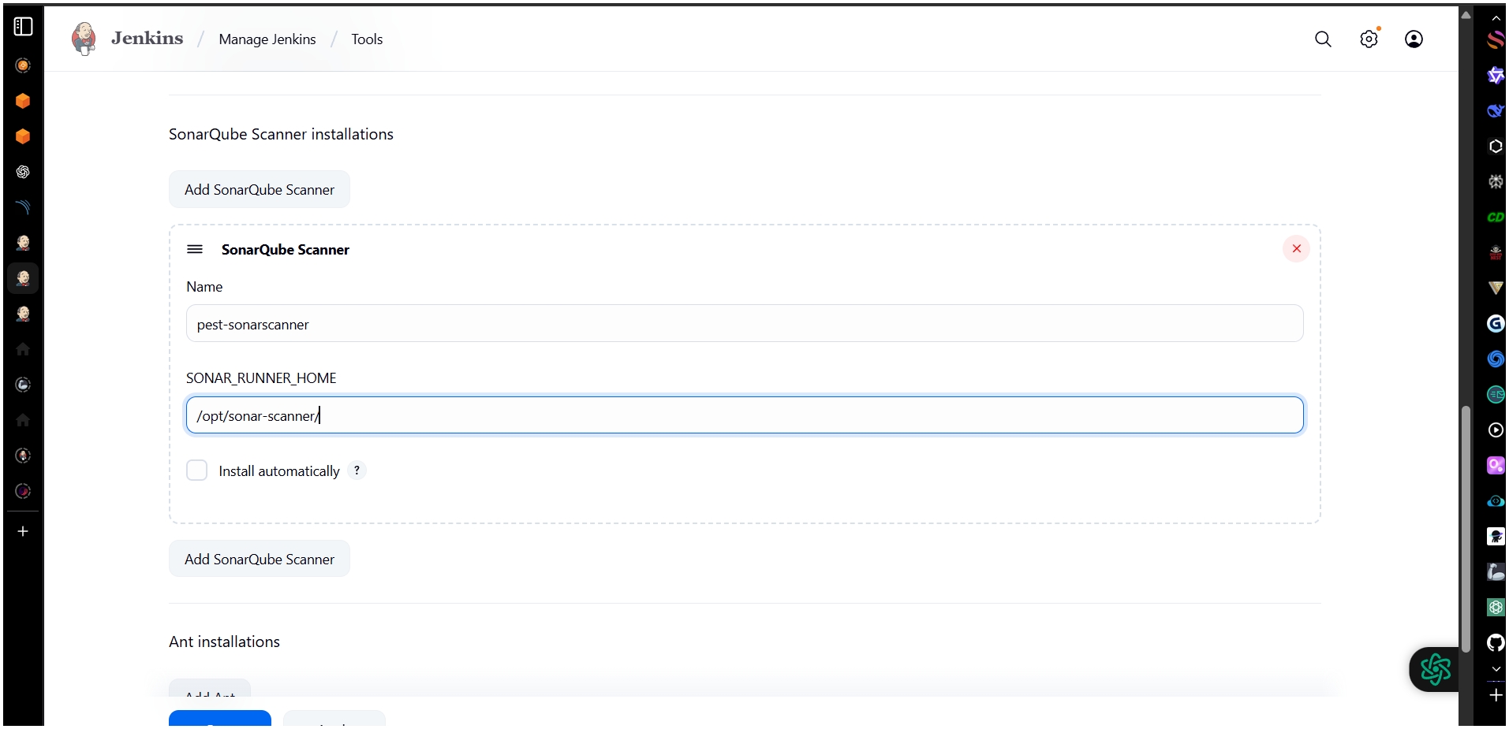
Paste This In Analysis Properties
sonar.projectKey=Sabear
sonar.projectName=Sabear
sonar.projectVersion=1.0
sonar.sources=/var/lib/jenkins/workspace/$JOB_NAME/src/
sonar.binaries=target/classes/com/visualpathit/account/controller/
sonar.junit.reportsPath=target/surefire-reports
sonar.jacoco.reportPath=target/jacoco.exec
sonar.java.binaries=src/main/java/com/visualpathit/account/
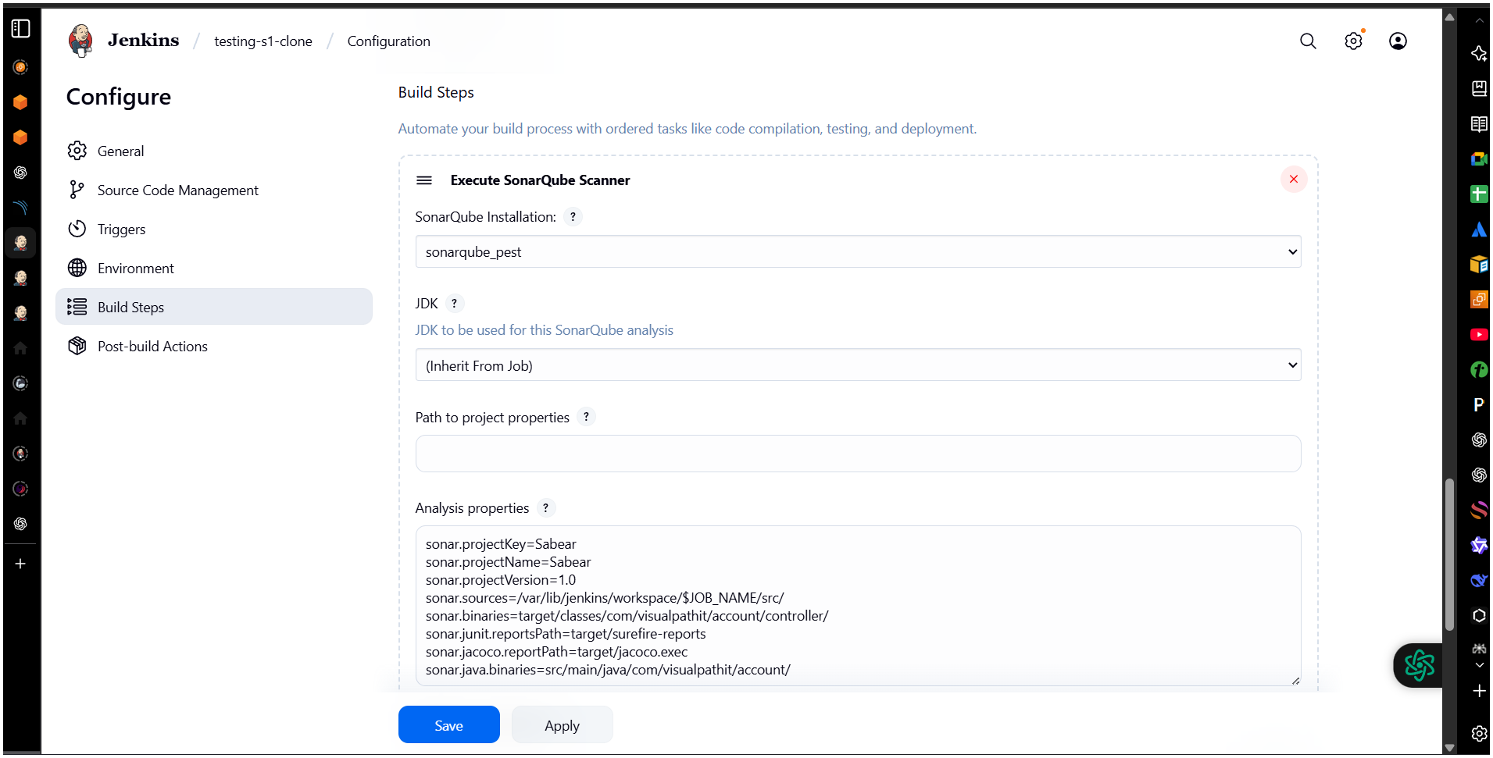

✅
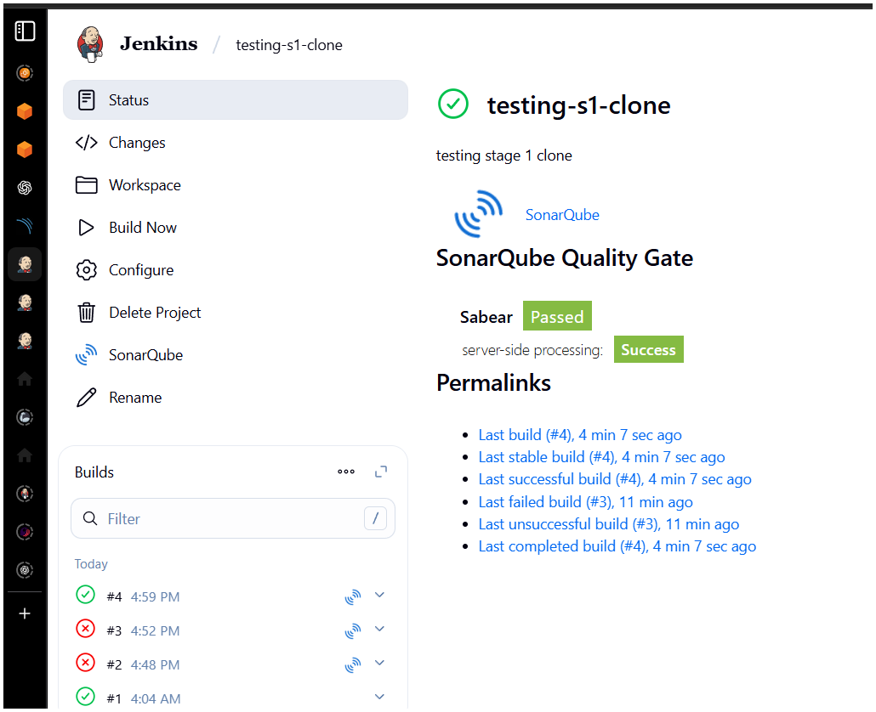
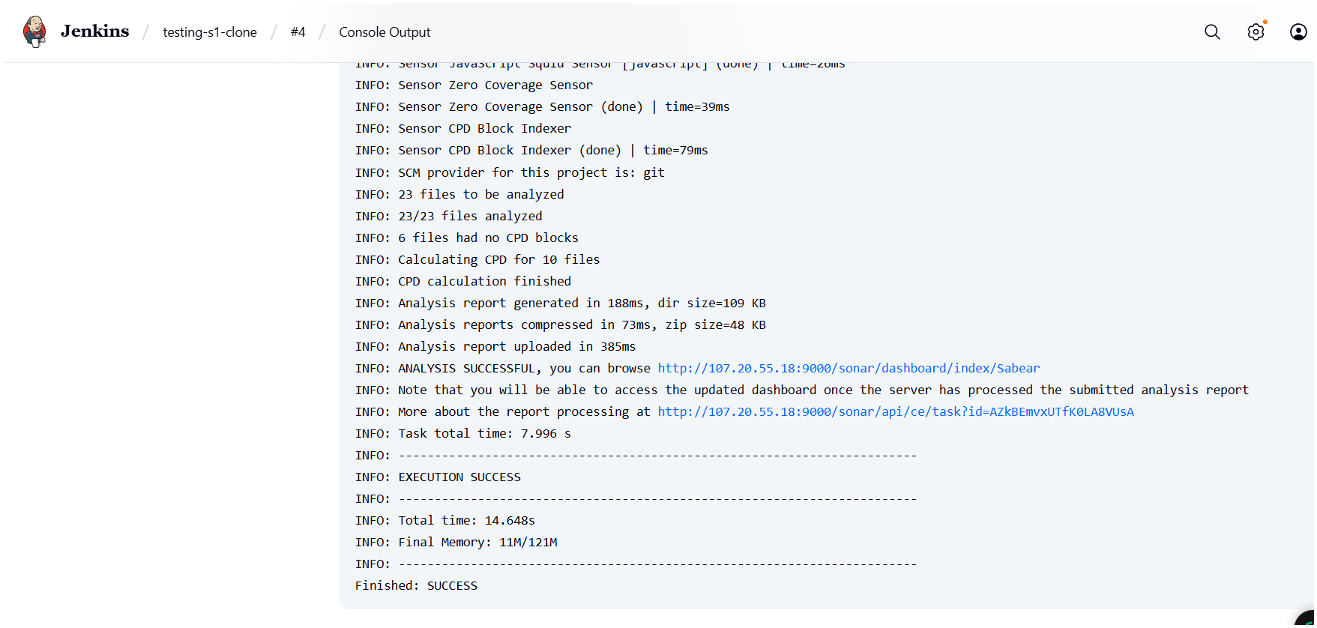

so far so good...!!
Seem like good news
checking SonarQube page…
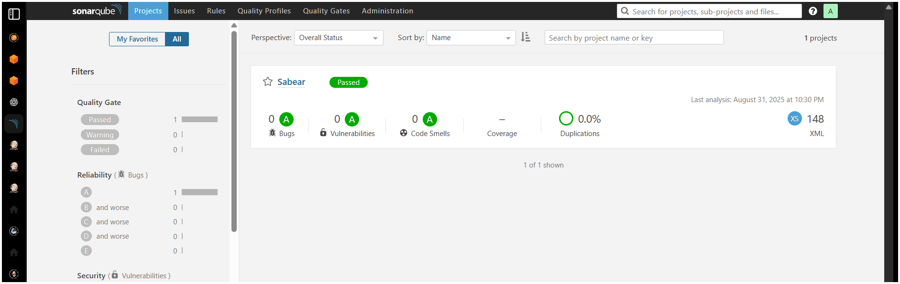
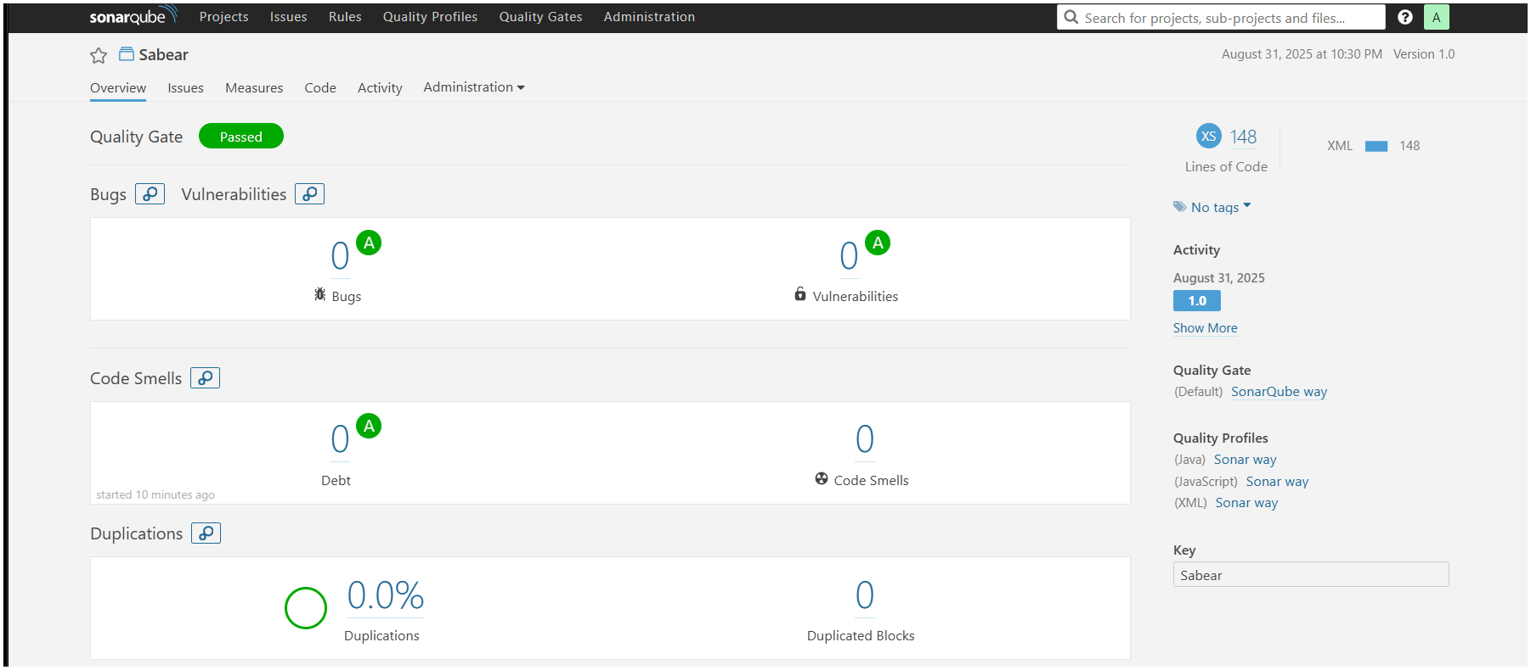

Now Here We Have Latest Method By Using Docker.

sudo -I
Yum -y install docker
Systemctl start docker
docker pull sonarqube
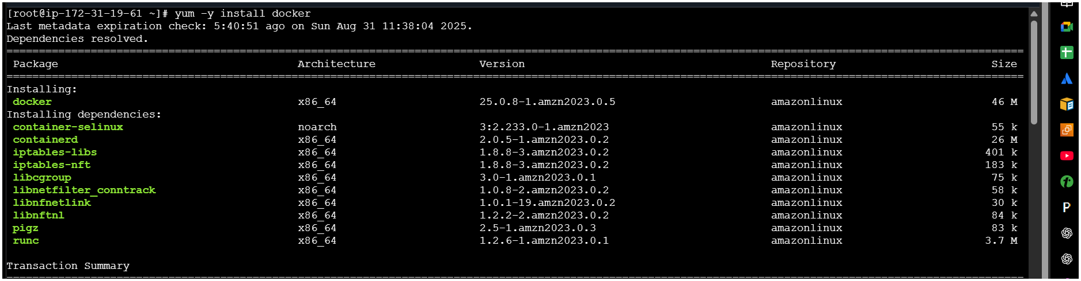

Systemctl start docker
docker pull sonarqube
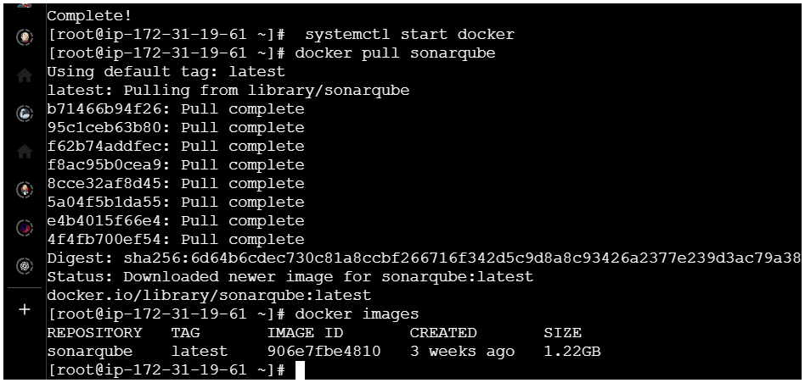
Here We’re Changing The Port No Of Docker From 9000 To 9001 Cause
9000 We ‘re Using Default For SonarQube…
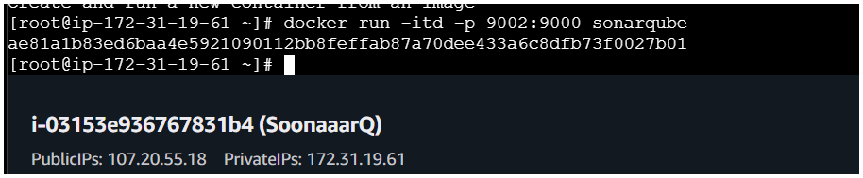
docker ps
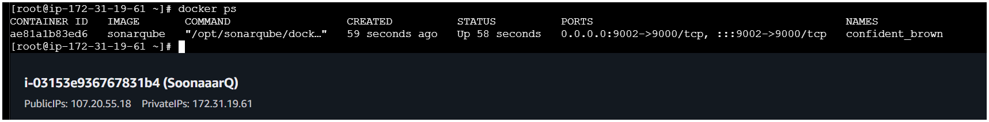
copy the ip address and paste at browser and at the last type :9002/

some changes needed to done
Path
cd conf/
Vi sonar-scanner.properties
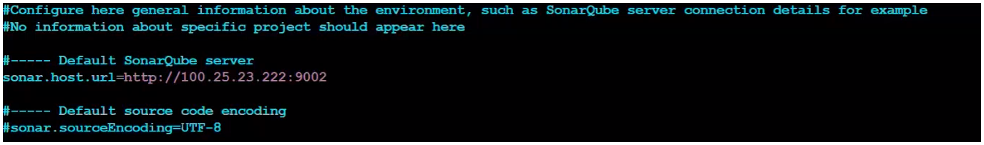
Another Change DashboardManage JenkinsSystem
Change the port no from 9000 (traditional method) TO 9002(new method port no)
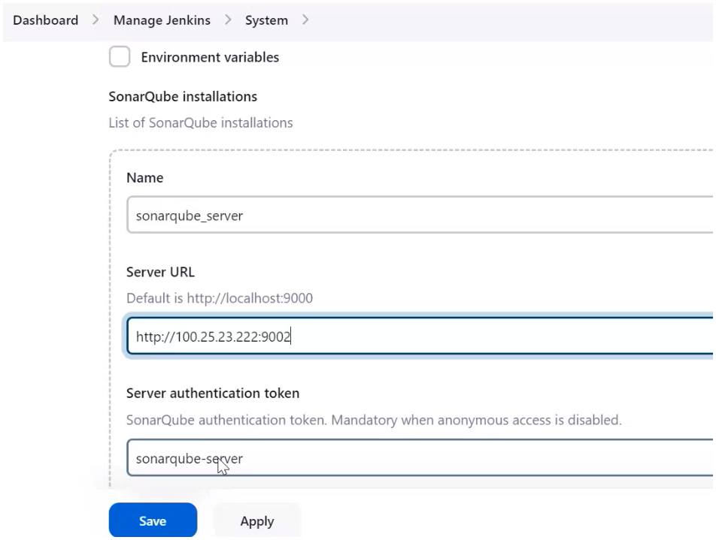
No try to login by using the ip address at last enter :9002/
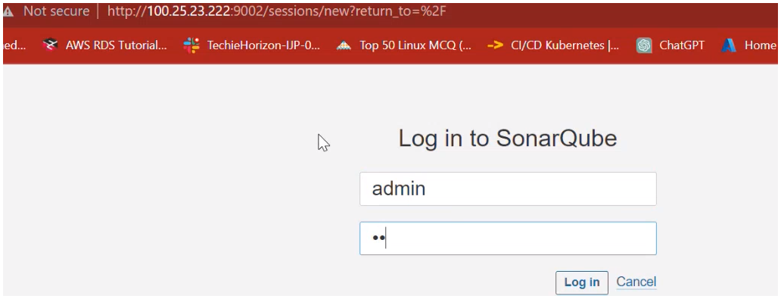
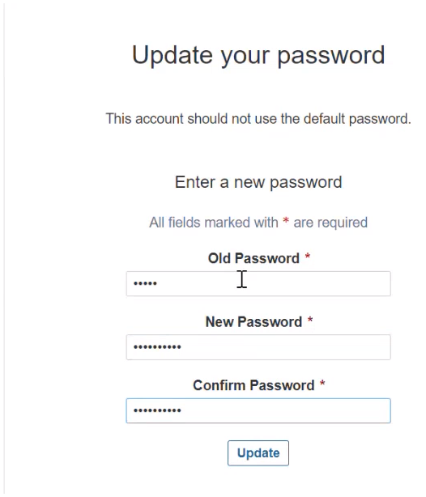
Home Page
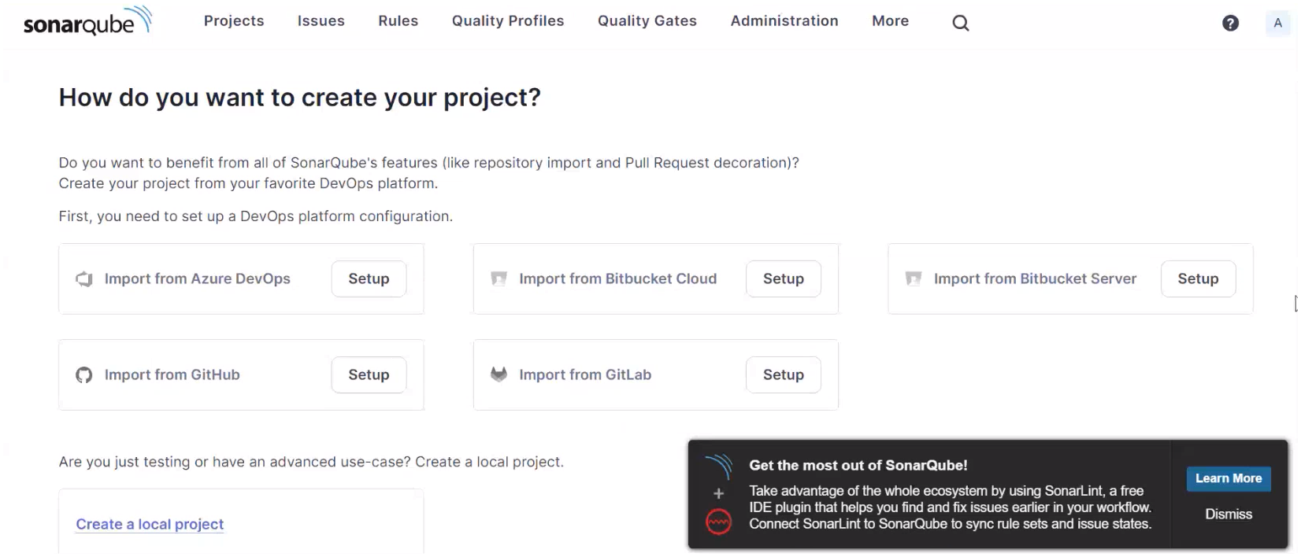
here we have generated token
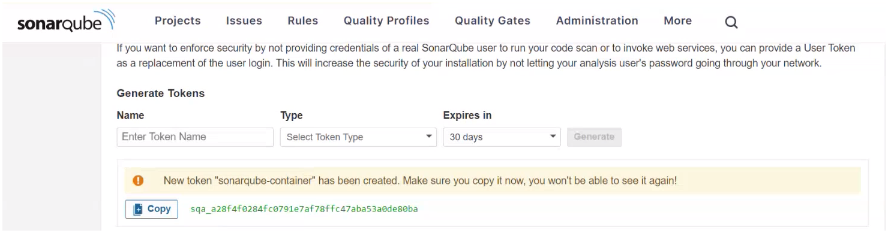
Add Credential
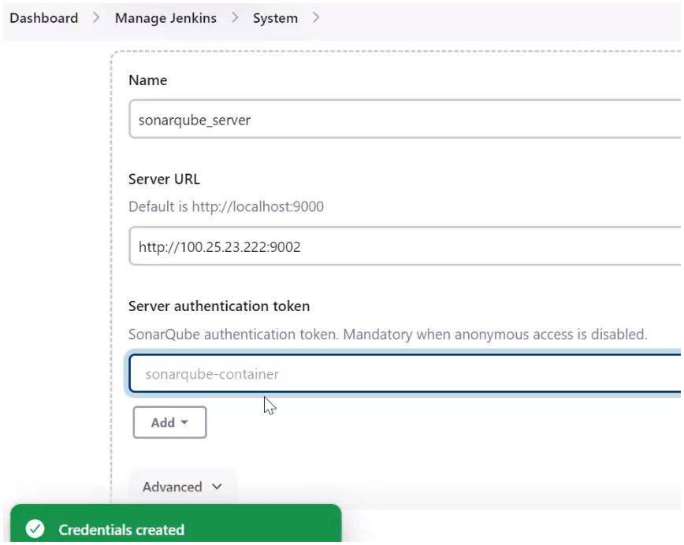
Now Build Your Job
good...! we have connect you SonarQube with latest method
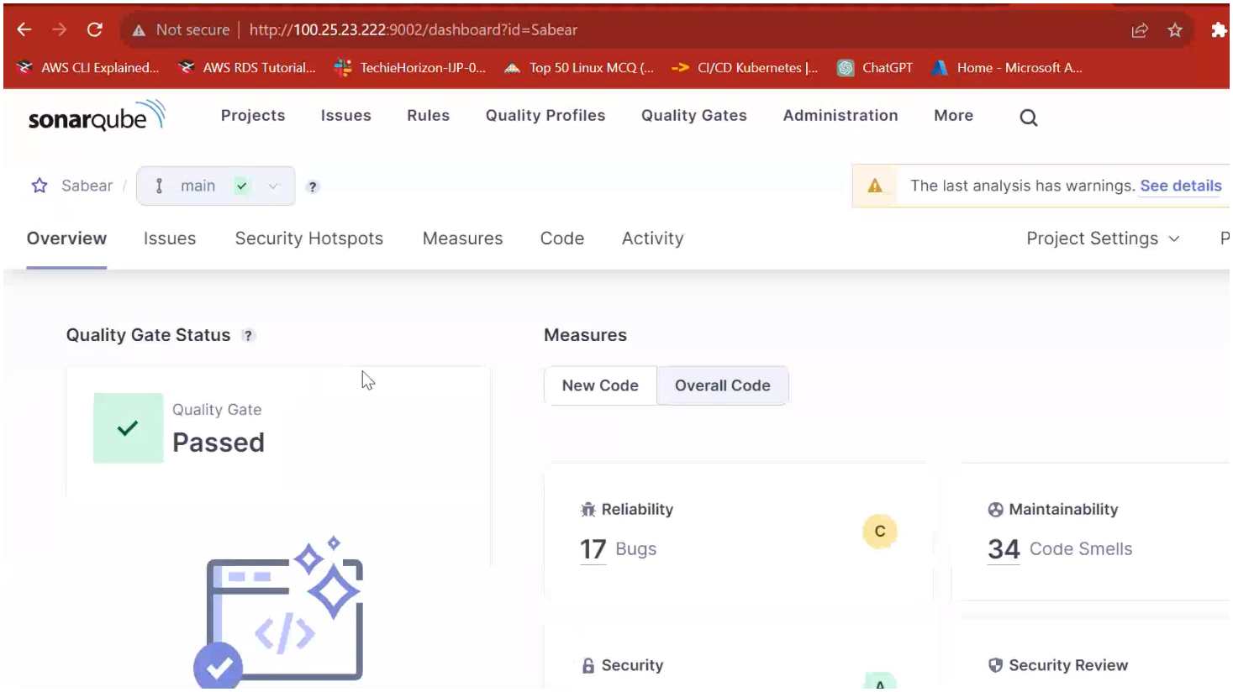

stage3: Slack Integration to send the alerts to slack. URL:
https://github.com/betawins/VProfile-1.git
Install plugin slack notification in jenkins
Go to your slack dashboard → apps → jenkins CI → configure → add channel
Step : Add Slack Credential to Jenkins
- Open Jenkins → Manage Jenkins → Manage Credentials
- Choose the correct domain (e.g., (global) or create one)
- Click Add Credentials
- Use the following settings:
  - Kind: Secret text
  - Secret: Paste the Slack Bot User OAuth Token
  - ID: slack_notification (or the ID you're using in the Slack config)
  - Description: Slack bot token
Click OK to save.

🔗 Step: Configure Slack in Jenkins
- Go to Manage Jenkins → Configure System
- Scroll down to the Slack section
- Enter:
  - Workspace: (optional, usually auto-filled)
  - Credential: select the ID you just added (slack_notification)
  - Default channel / member ID: e.g., #jenkins-integration or @yourself
- Test with "Test Connection" button (if available)

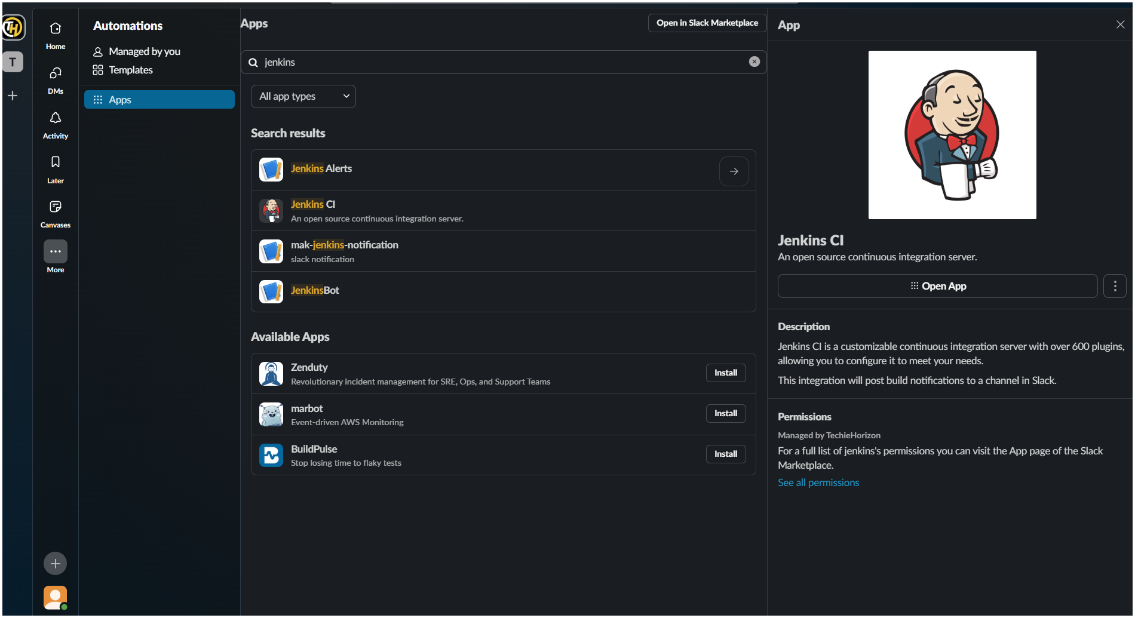
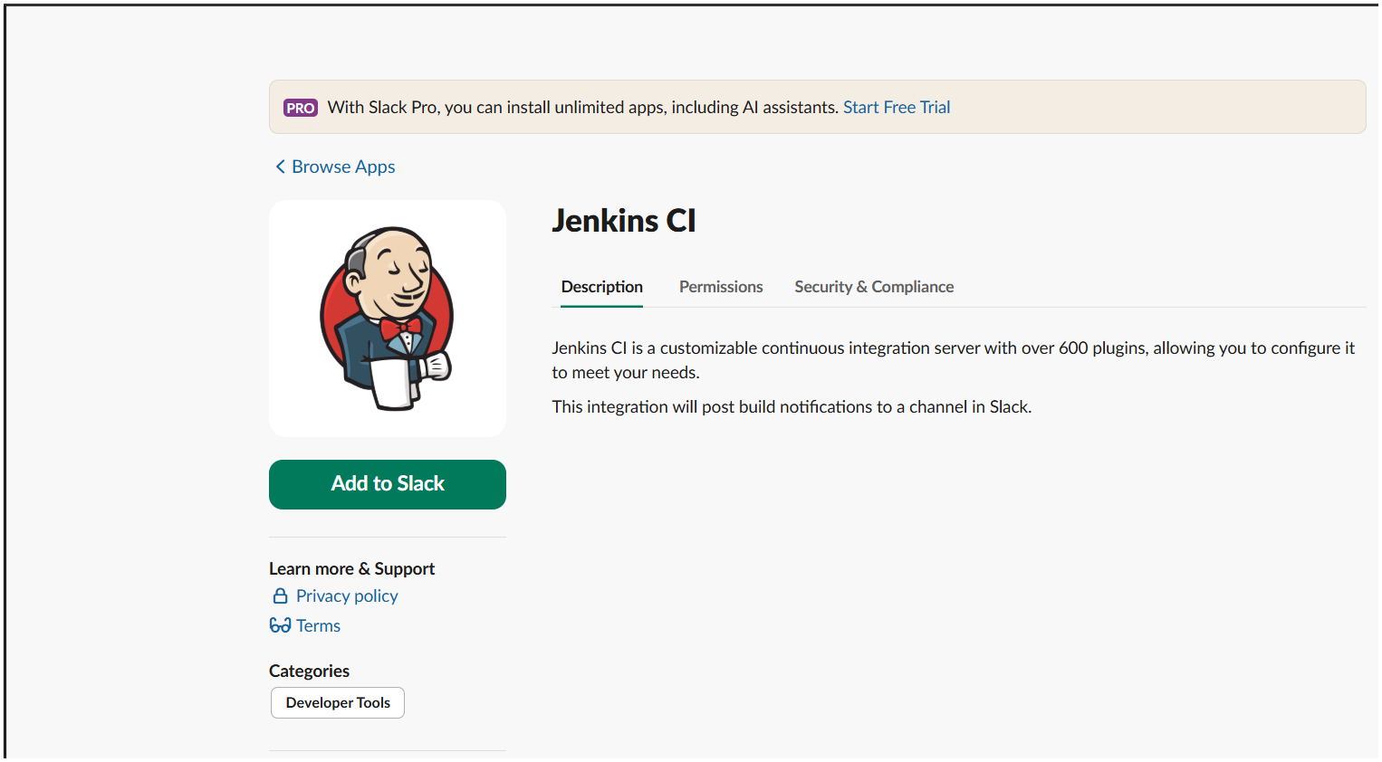
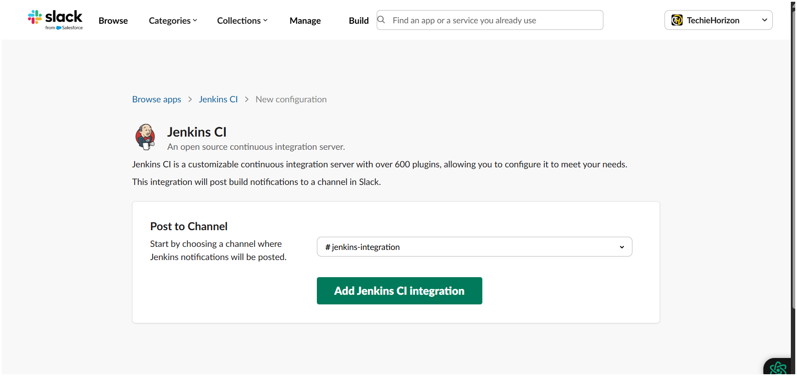
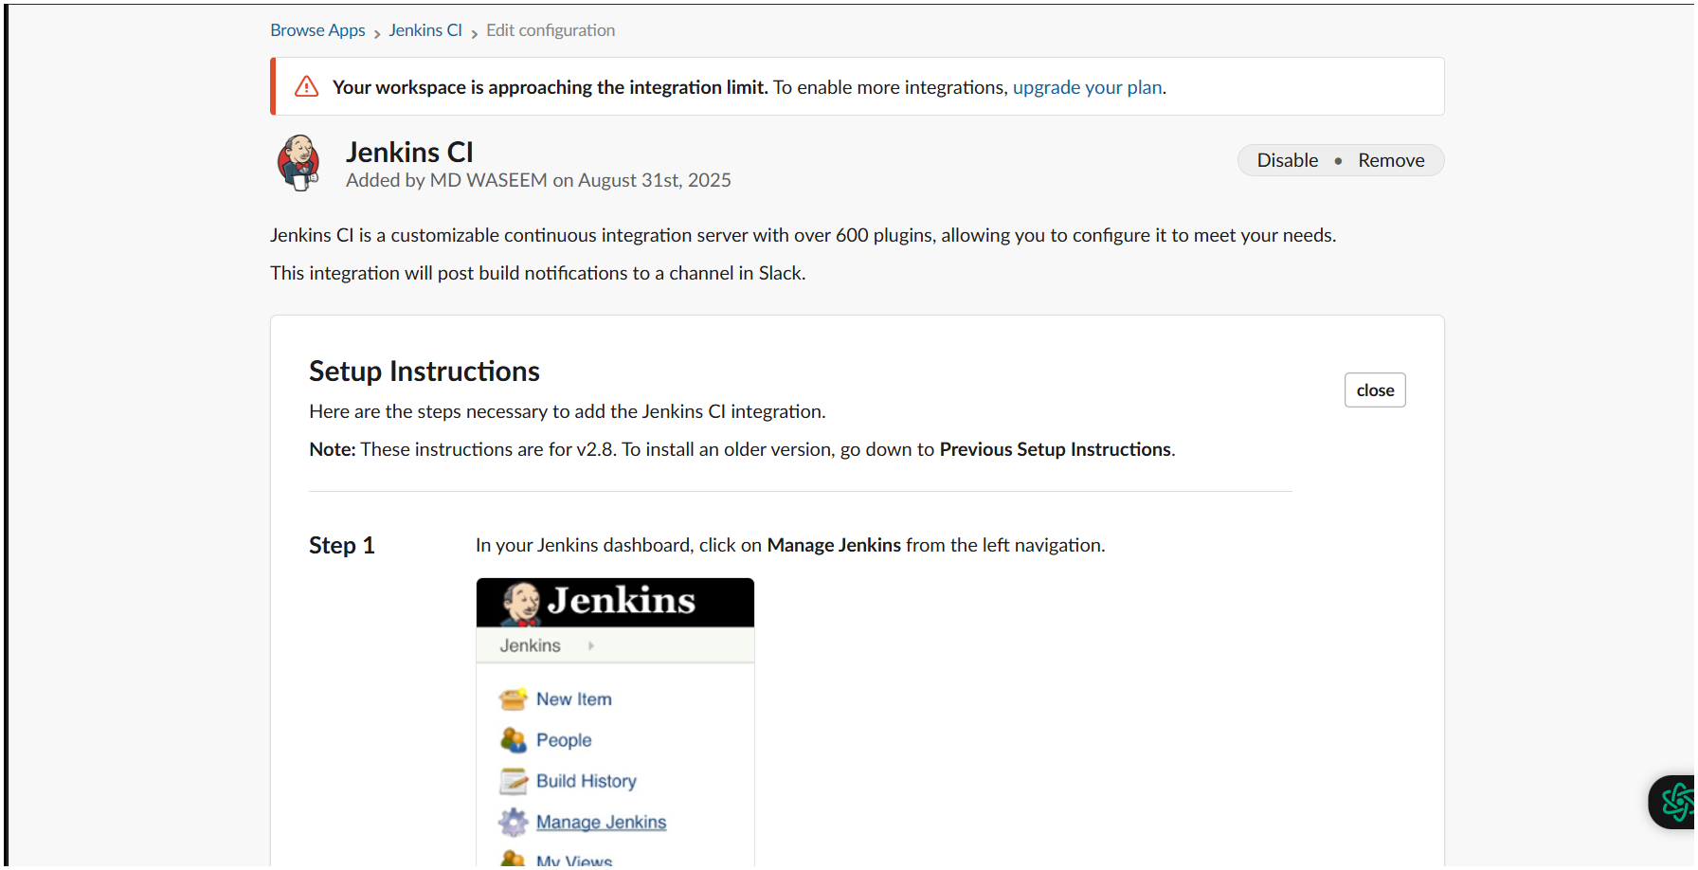
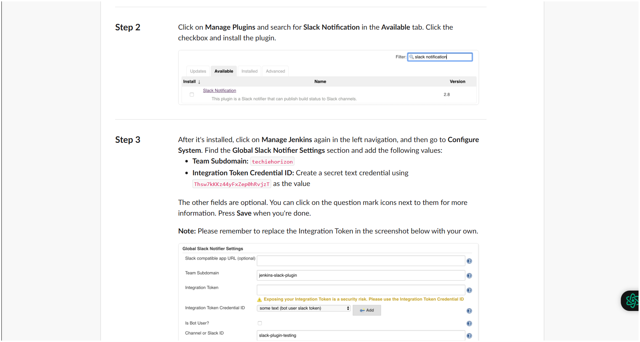
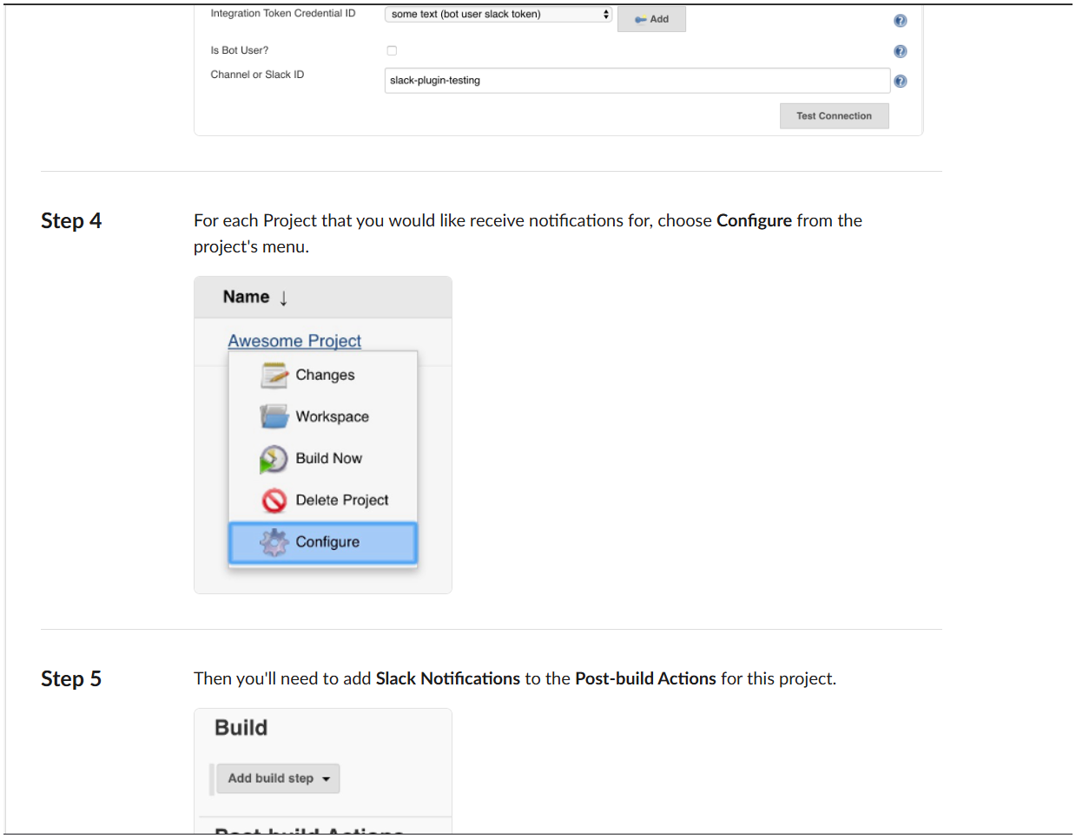
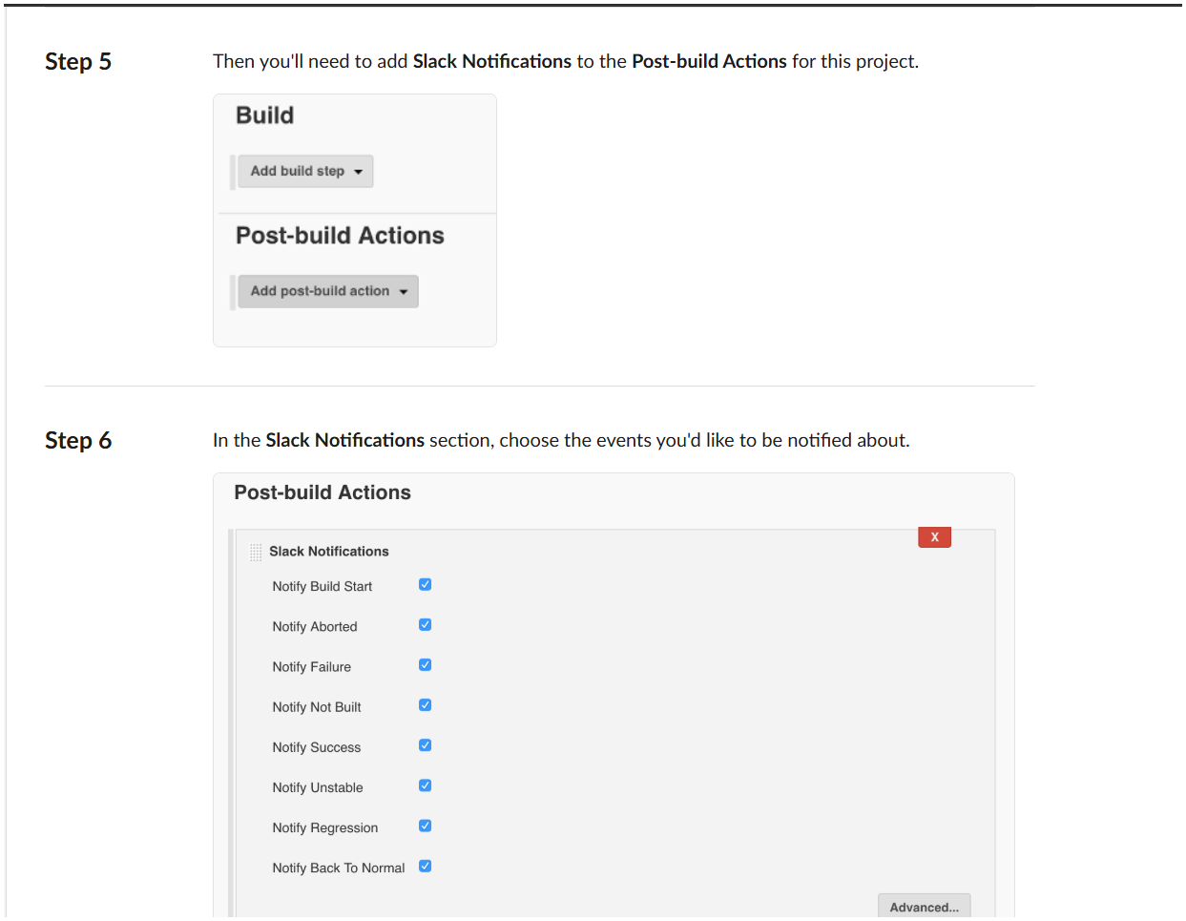
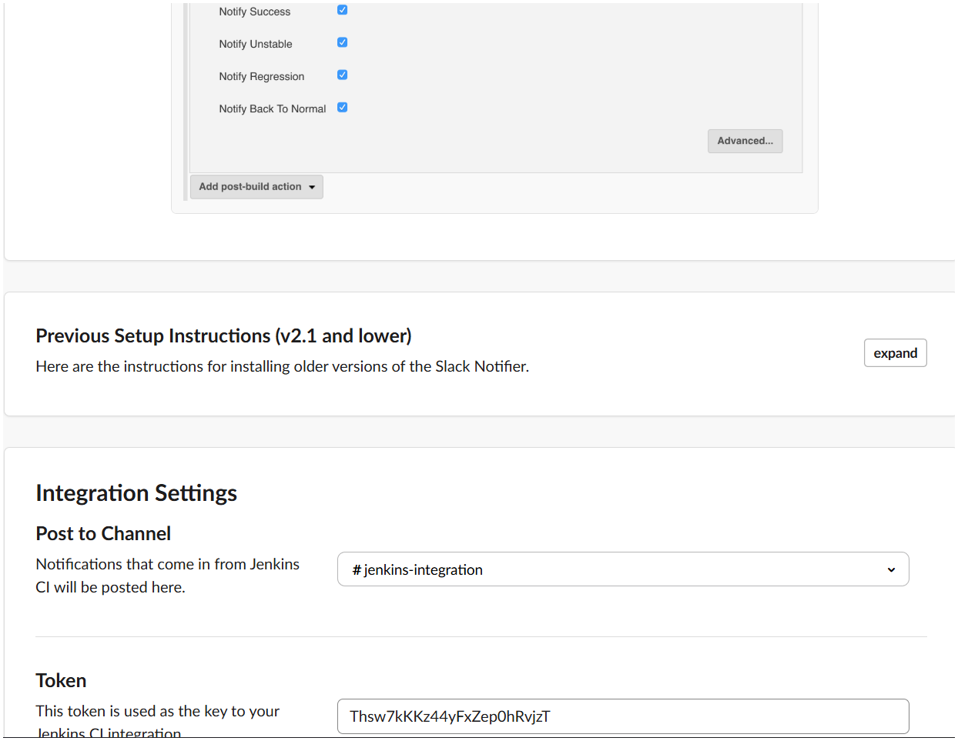
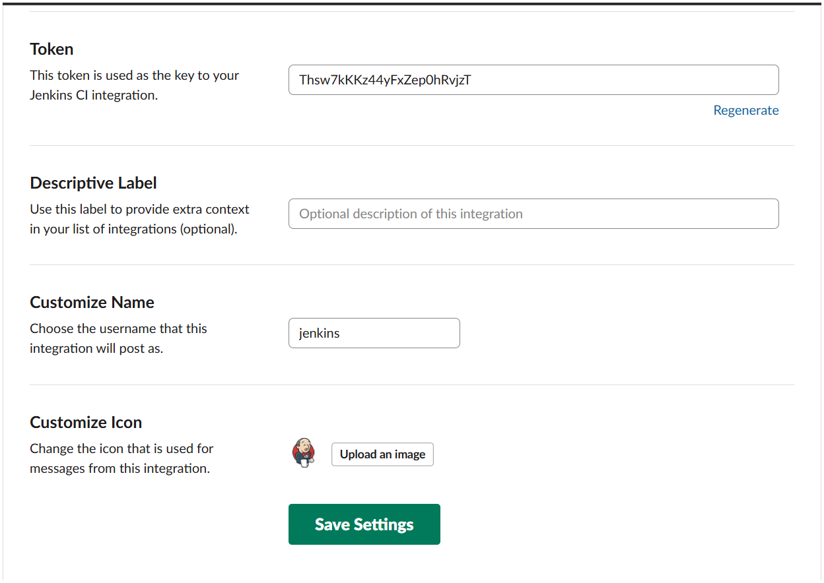

Add credential 